Compound Sentence

✅ Definition:
# Source: Chatgpt (GPT-4-turbo) at [7/29/2025]
A compound sentence contains two or more independent clauses joined by a:
- Coordinating conjunction (FANBOYS),
- Semicolon, or
- Conjunctive adverb (e.g., however, therefore).
🔹 Each clause can stand alone as a complete sentence.

🔗 Common Coordinating Conjunctions (FANBOYS):
# Source: Chatgpt (GPT-4-turbo) at [7/29/2025]
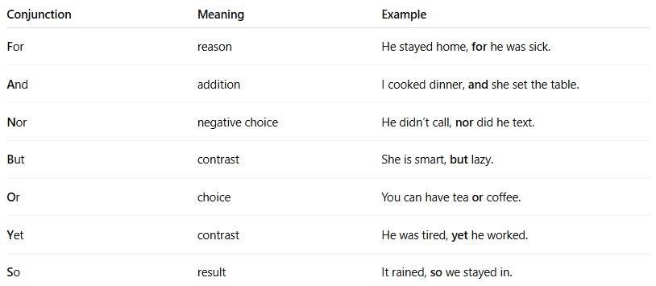
Conjunction | Meaning | Example
For | reason | He stayed home, for he was sick.
And | addition | I cooked dinner, and she set the table.
Nor | negative choice | He didn’t call, nor did he text.
But | contrast | She is smart, but lazy.
Or | choice | You can have tea or coffee.
Yet | contrast | He was tired, yet he worked.
So | result | It rained, so we stayed in.

🧩 Structure:
# Source: Chatgpt (GPT-4-turbo) at [7/29/2025]

Independent Clause + , + FANBOYS + Independent Clause
OR
Independent Clause + ; + Independent Clause
OR
Independent Clause + ; + Conjunctive Adverb + , + Independent Clause

✏️ Examples of Compound Sentences:
# Source: Chatgpt (GPT-4-turbo) at [7/29/2025]
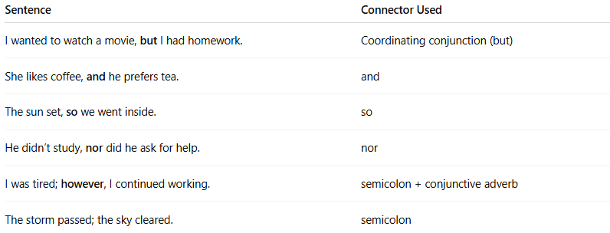
Sentence | Connector Used
I wanted to watch a movie, but I had homework. | Coordinating conjunction (but)
She likes coffee, and he prefers tea. | and
The sun set, so we went inside. | so
He didn’t study, nor did he ask for help. | nor
I was tired; however, I continued working. | semicolon + conjunctive adverb
The storm passed; the sky cleared. | semicolon

⚠️ Common Mistake:
# Source: Chatgpt (GPT-4-turbo) at [7/29/2025]
🚫 Comma splice – using a comma alone without a conjunction:
❌ I was tired, I went to bed.
✅ I was tired, so I went to bed.
✅ I was tired; I went to bed.

🧠 Quick Check: Compound or Not?
# Source: Chatgpt (GPT-4-turbo) at [7/29/2025]
- I love pizza, and she likes pasta. ✅
- Although it was late, we stayed outside. ❌ (Complex)
- He opened the window; it was hot. ✅
- She is quiet but very smart. ❌ (Simple – one clause, compound predicate)

